Experiment 18C
Measuring Reaction Rate Using Volume of Gas Produced

Purpose:

To measure how the changes of the volume of a gas produced from a reaction mixture at regular time intervals change in relation to temperature; and to interpret the results of this experiment and obtain an overall rate of the reaction.

Procedure:

See experiment 18C procedure for chemistry 12.
The only change in procedure is that this experiment is not actually performed, as we don’t have access to the necessary equipment. This lab is performed in theory and all resulting data is given.

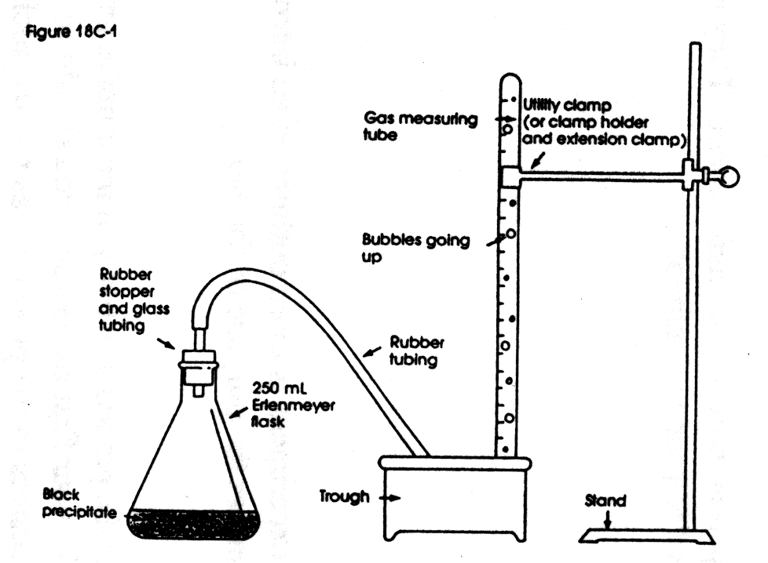

Data and Observations:

 | Temp = 20ºC | Temp = 30ºC | Temp = 10ºC | Temp = 20ºC | Temp = 20ºC
 | [Bleach] = Full Strength | [Bleach] = Full Strength | [Bleach] = Full Strength | [Bleach] = 1/2 Strength | [Bleach] = 1/4 Strength
Time (s) | Volume of O2 (mL) | Volume of O2 (mL) | Volume of O2 (mL) | Volume of O2 (mL) | Volume of O2 (mL)
0 | 1.0 | 0.0 | 0.0 | 0.0 | 0.0
30 | 3.3 | 3.0 | 0.0 | 0.0 | 0.0
60 | 8.6 | 38.0 | 0.0 | 3.0 | 0.8
80 |  | 50.0
90 | 24.3 |  | 0.0 | 7.0 | 1.7
120 | 40.7 |  | 3.0 | 13.0 | 4.6
137 | 50.0
150 |  |  | 8.5 | 18.4 | 7.0
180 |  |  | 13.8 | 23.0 | 10.0
210 |  |  | 19.8 | 29.5 | 13.2
240 |  |  | 25.5 | 37.0 | 16.5
270 |  |  | 31.5 | 42.0 | 19.2
300 |  |  | 38.0 | 47.5 | 22.2
322 |  |  |  | 50.0
330 |  |  | 42.5 |  | 25.2
360 |  |  | 47.0 |  | 29.0
385 |  |  | 50.0
390 |  |  |  |  | 32.8
420 |  |  |  |  | 38.0
450 |  |  |  |  | 42.6
480 |  |  |  |  | 45.5
510 |  |  |  |  | 49.5
526 |  |  |  |  | 50.0

Calculations:

Average rate for conditions: Temperature = 20ºC, Bleach Concentration = Full Strength

Average rate for conditions: Temperature = 30ºC, Bleach Concentration = Full Strength

Average rate for conditions: Temperature = 10ºC, Bleach Concentration = Full Strength

Average rate for conditions: Temperature = 20ºC, Bleach Concentration = 1/2 Strength

Average rate for conditions: Temperature = 20ºC, Bleach Concentration = 1/4 Strength

 | Temp = 20ºC | Temp = 30ºC | Temp = 10ºC | Temp = 20ºC | Temp = 20ºC
 | [Bleach] = Full Strength | [Bleach] = Full Strength | [Bleach] = Full Strength | [Bleach] = 1/2 Strength | [Bleach] = 1/4 Strength
Reaction  Rate | 21.9 mL/min | 38 mL/min | 7.79 mL/min | 9.32 mL/min | 5.70 mL/min

Average reaction rate increase factor for each 10ºC increase in temperature:

Average reaction rate decrease factor for each 10ºC decrease in temperature:

The average reaction rate increase for every increase in 10ºC is approximately 2.3 times, whereas the average reaction rate decrease for every decrease in 10ºC is approximately 2.1 times (0.47).
Factor change in the rate for when the concentration of bleach was changed:

For every decrease by one half in the bleach’s concentration, the rate of the reaction would decrease by an average of 2.0 times.

Questions:

- The reason you should not mix bleach with any other household cleaners that contain acid is because it will cause the bleach will then react with the acid and give off poisonous chlorine gas, which was used as a chemical weapon during WWII.
- Considering that the reaction rate decreases by a factor of two times for every 50% decrease in bleach (sodium hypochlorite) concentration, we can then assume that for a 1/10 decrease in the concentration the time taken (the reaction rate) for the reaction to occur would be 10 times longer. Therefore, if the bleach concentration were 10%, then we know the same reaction as done in this experiment would take approximately 10 times longer than when a bleach at 100% concentration.

Conclusion:

The results of this experiment clearly show that temperature and concentration do have an effect on the rate of a chemical reaction. We have proven, within a small margin of error, that a temperature increase of 10ºC approximately will double the rate at which a reaction will occur; likewise we have also shown that when the concentration of one of the reactants is reduced by 50%, the reaction will also slow by a factor of two.

